QUERIES 19 T0 25

19. Query to display the following for each employee earns < Salary> monthly but wants < 3 \* Current Salary >. Label the Column as Dream Salary

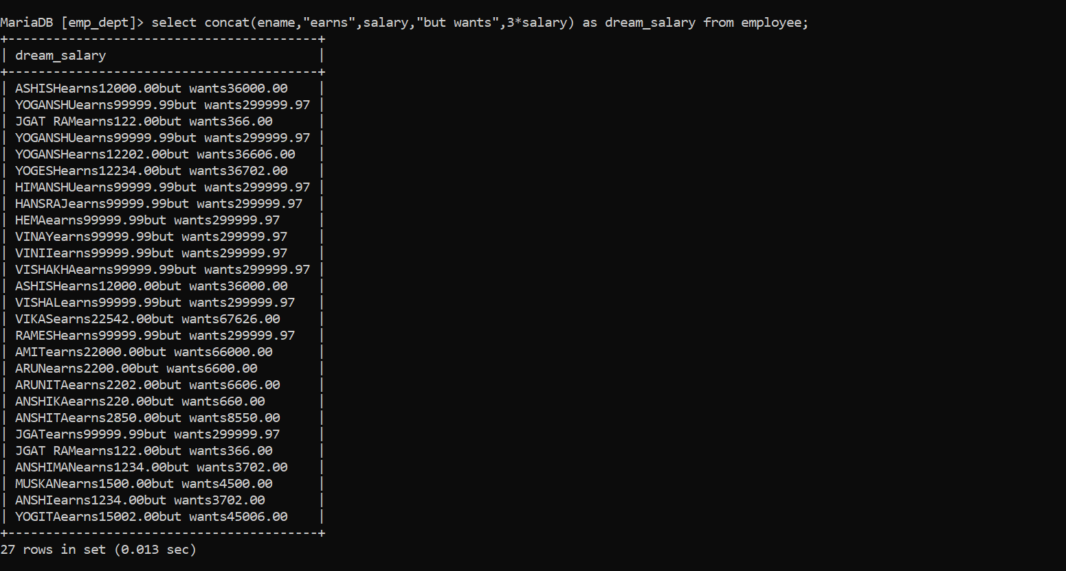

20. Query to display Name with the 1st letter capitalized and all other letter lower case and length of their name of all the employees whose name starts with ‘J’, ’A’ and ‘M’.

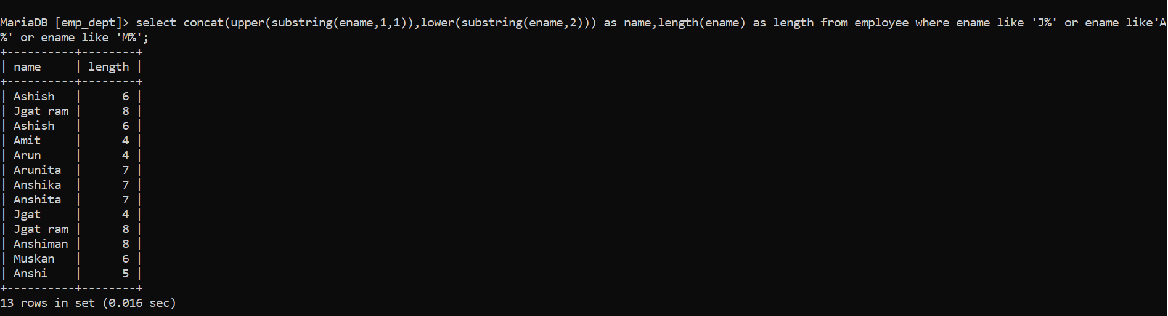

21. Query to display Name, Hire Date and Day of the week on which the employee started.

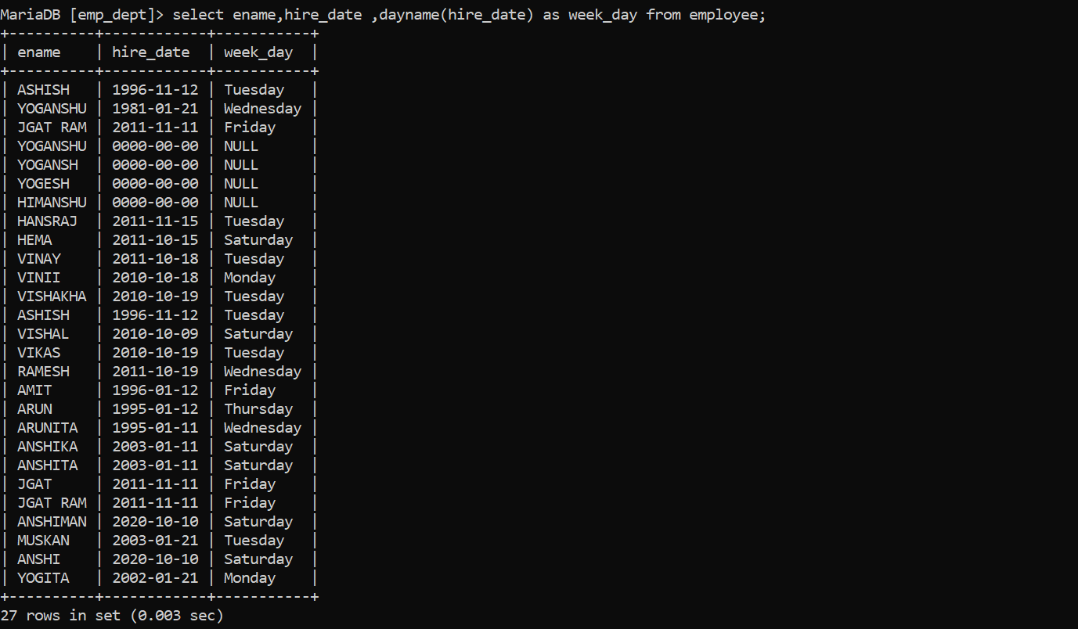

22. Query to display Name, Department Name and Department No for all the employees

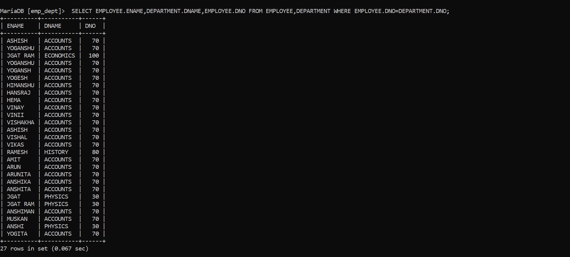

23. Query to display Unique Listing of all Jobs that are in Department number 30.

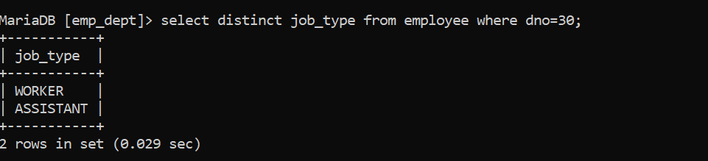

24. Query to display Name, Dept Name of all employees who have an ‘A’ in their name

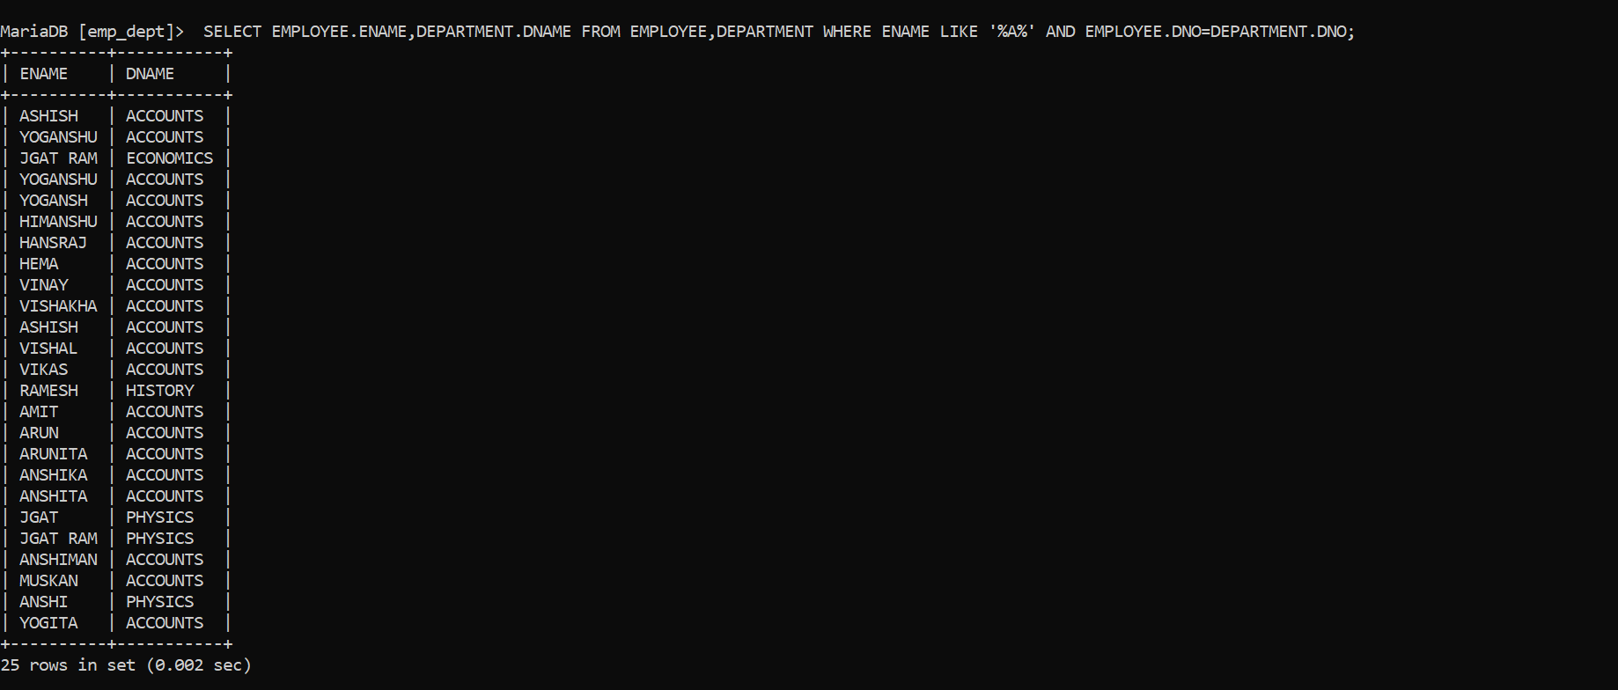

25. Query to display Name, Job, Department No. And Department Name for all the employees working at the Dallas location. 26. Query to display Name and Employee no. Alon

